# **Image Processing Speed Improvement Using Sensor Fusion for Autonomous Driving System**

Wonmook Jeong*1)·Jungu Ji2)

*1600, Chungjeol-ro, Byeongcheon-myeon, Dongnam-gu, Cheonan-si, Chungcheongnam-do, Republic of Korea*

**Abstract** : Template matching is a method for image recognition. Existing template matching algorithms compare all two-dimensional pixels in an image to measure their similarity to the comparison object (template). This can be seen as an inefficient way of comparing insignificant parts of an image. This inefficient method can be used more efficiently by setting the region where the object exists as an ROI (region of interest) through LiDAR and comparing only that region.

**Key words** : Sensor Fusion, Image processing, Autonomous Driving, ROI(region of interest), Template Matching

**1. INTRODUCTION[1]**

Image classification methods include deep learning, machine learning, and template matching. For image classification, finding an object in the view must be preceded. In the traditional method of finding objects, template matching scans the entire image against a template image (feature image). This is the simplest way to find an object, but it is inefficient in terms of computer processing speed and processing time because it scans unnecessary areas. The most important thing in autonomous driving is the fast compute time for quick response to the environment, and to improve this, this paper mainly aims to improve the algorithm using LiDAR-Vision sensor fusion.

**2. SENSOR PROCESSING**

Dataflow is working like Fig. 1. This section describes how each sensor processes data.

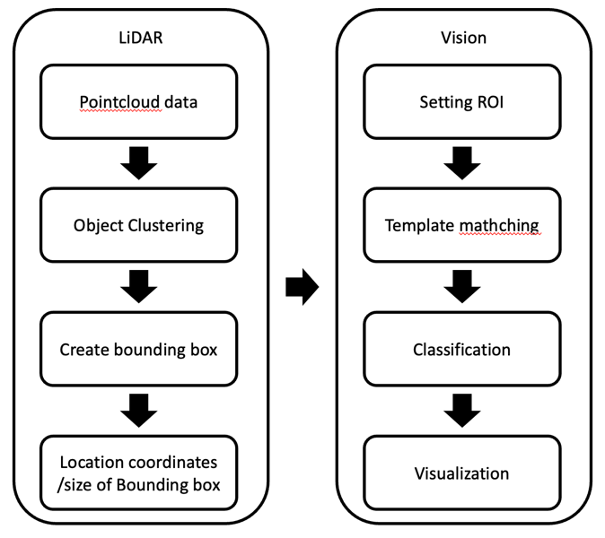

Fig. 1 Flow Chart of Algorithm

**2.1 Clustering**

A clustering algorithm was used together for a group local point cloud cluster. Open3D implements DBSCAN, a density-based clustering algorithm of reference paper [3].

**2.2 Calibration**

The rider and camera are fixed to each other. Since the lidar and camera directions are the same, the camera direction sets the x-axis direction, which is the front of the lidar, and the bounding box created by clustering is projected perpendicular to the y-z plane for calibration.

**2.2.2 Template Matching Method**

Template matching is a digital image processing technique for findi ng small parts of an image that match a template image. OpenCV provides 6 methods for template matching. I used the TM_CCOEFF_NORMED method, which is robust to light changes [2].

The TM_CCOEFF_NORMED method performs template matching using the expression shown in (1) below which is robust to light changes

(1)

**3. Experiment Environment**

The vision sensor was Logitech C922n, and the lidar used Velodyne VLP 16, and the specifications of each sensor are as table 1.

|  |  |  |
| --- | --- | --- |
|  | VLP 16 | Logitech C922n |
| Type | LiDAR | CAMERA |
| Range | 360° | 78° |
| Frequency | 100hz | 60fps |
| Resolution | 0.2° / 1° | 1920 x 1080 |
| Protocol | Ethernet | USB |

table 1 Specifications of the equipment used in the experiment

**4. Result**

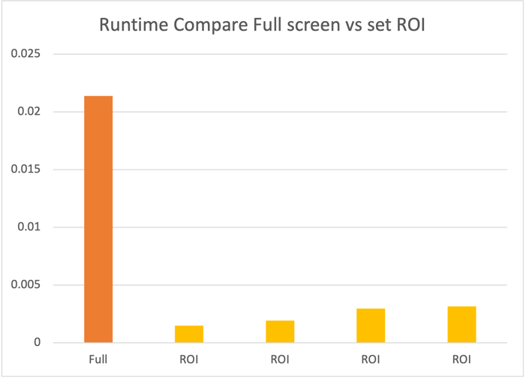

Fig. 2 Runtime(sec) compare Full screen & ROI

The above experiment (Fig. 2) showed an average speed improvement of 7 to 14 times.

The result will be different depending on the ratio of the area occupied by the template in the ROI, but it is faster than when no ROI is set.

ACKNOWLEDGEMENT

This work was supported by the University Innovation Support Project in 2020.

**References**

[1] Hyungi Kim, Estimate Position of Multiple Objects based on 3D LiDAR and Camera Sensor fusion (한국자동차공학회 춘계학술대회) 764-766, 3 pages , The Korean Society Of Automotive Engineers, 2019

[2] TM book, R. Brunelli, Template Matching Techniques in Computer Vision: Theory and Practice, Wiley, ISBN 978-0-470-51706-2, 2009

[3] Ester and H.-P. Kriegel and J Sander and X. Xu, A density-based algorithm for discovering clusters in large spatial databases with noise, KDD, 1996.

1. * E-mail : jwonmook@gmail.com